
QUALITY ALERT

Customer: EZ PVC - Amerilux Date: March 25, 2024
Die: 15191 / 15192 Colour: ALL
Type of Complaint: EZ PVC - AmeriLux REJECETED

Q.A # Q.I.R # CUSTOMER NCR #

Description: Customer REJECTED The panels are not laying flush when snap in together

THE EGDE GROWN UP

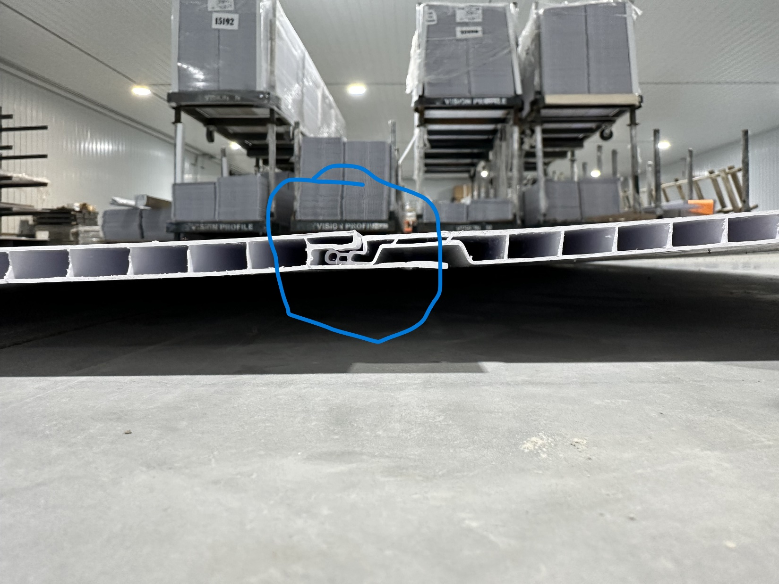

PLEASE MAKE SURE THE PANELS TO BE FLUSH WHEN SNAP IN
BY SIGNING BELOW, YOU ACKNOWLEDGE THE PROBLEM ABOVE AND AGREE TO MONITOR THIS ISSUE IN FUTURE PRODUCTION RUNS.
DAY SHIFT |  | AFTERNOON SHIFT |  | NIGHT SHIFT
NAME | SIGNATURE | NAME | SIGNATURE | NAME | SIGNATURE

